**NBTX10442_LAB-A_WEEK-3**

Q1.

#include<stdlib.h>

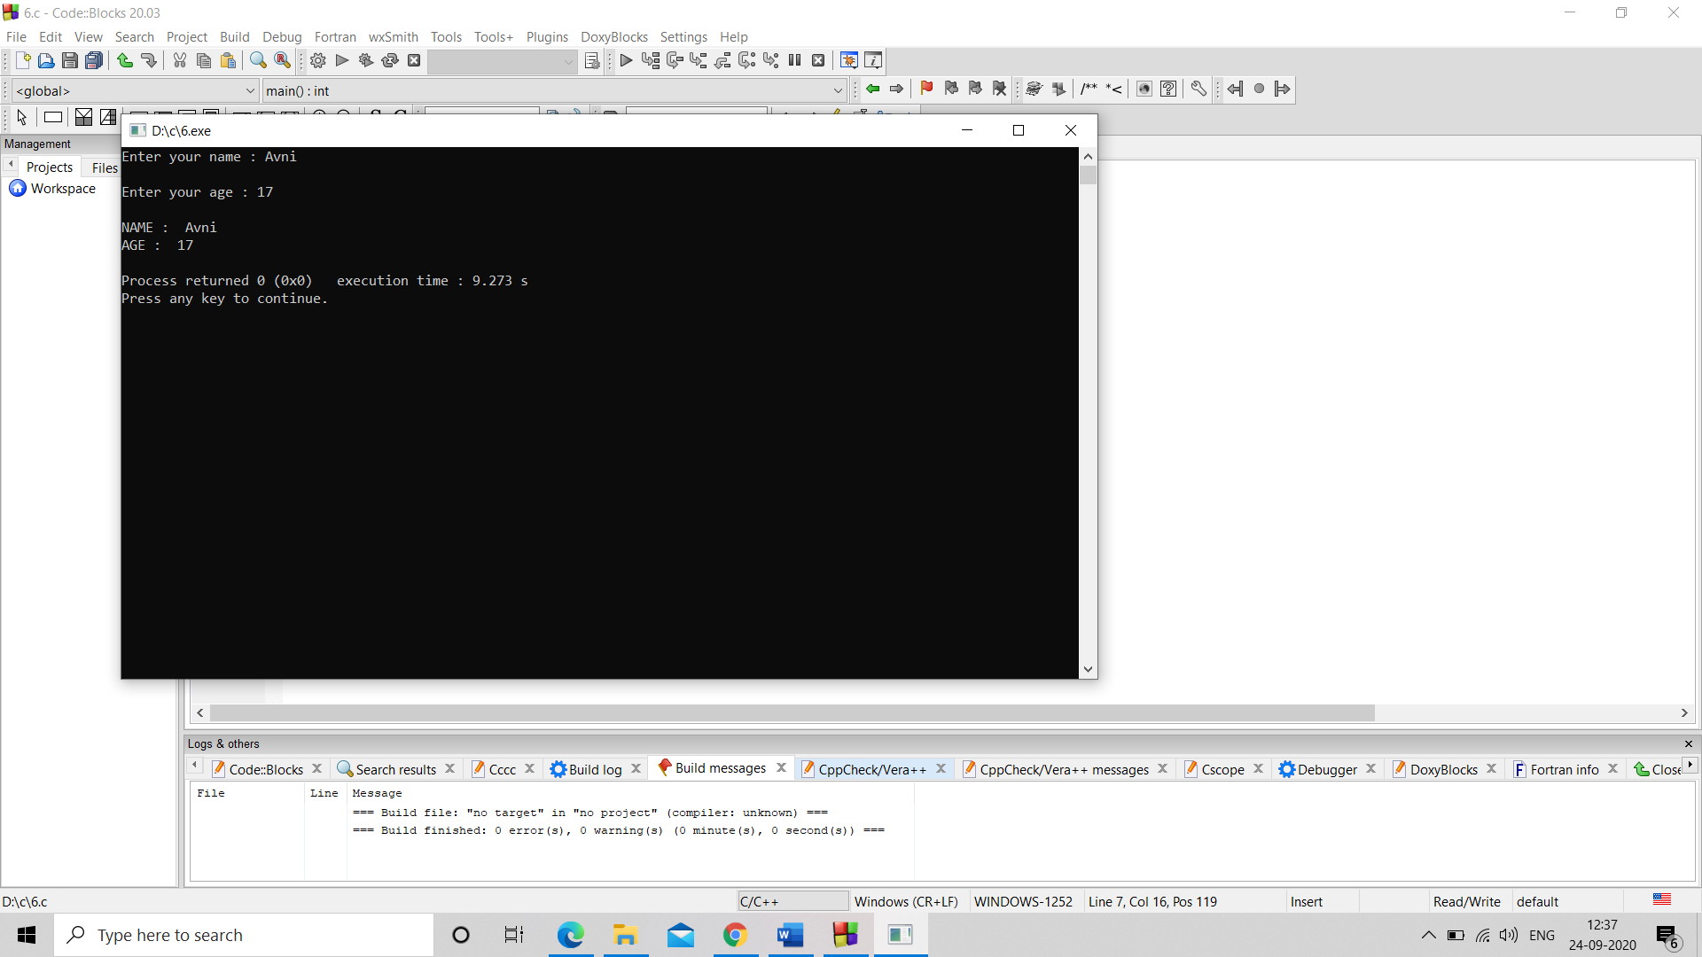#include<stdio.h>

int main()

{ char a[10];

int b;

printf("Enter your name : ");

scanf("%s",&a);

printf("\n");

printf("Enter your age : ");

scanf("%d",&b);

printf("\n");

printf("NAME : ");

printf("%s",a);

printf("\n");

printf("AGE : ");

printf("%d",b);

printf("\n");

return 0;

}

Q2.

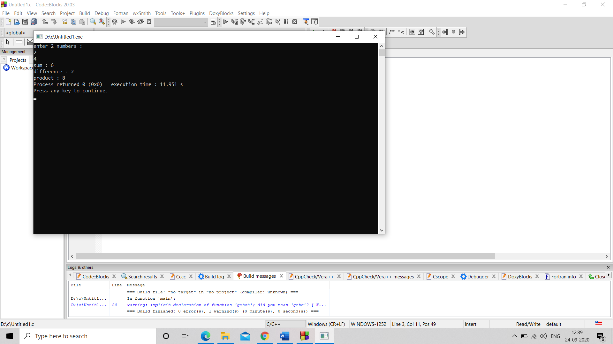#include<stdlib.h>

#include<stdio.h>

int main()

{ int a,b,c,d,e;

printf("enter 2 numbers : \n");

scanf("%d",&b);

scanf("%d",&c);

a=b+c;

d=c-b;

e=b*c;

printf("sum : ");

printf("%d",a);

printf("\n");

printf("difference : ");

printf("%d",d);

printf("\n");

printf("product : ");

printf("%d",e);

return 0;

}

Q3.

#include<stdlib.h>

#include<stdio.h>

int main()

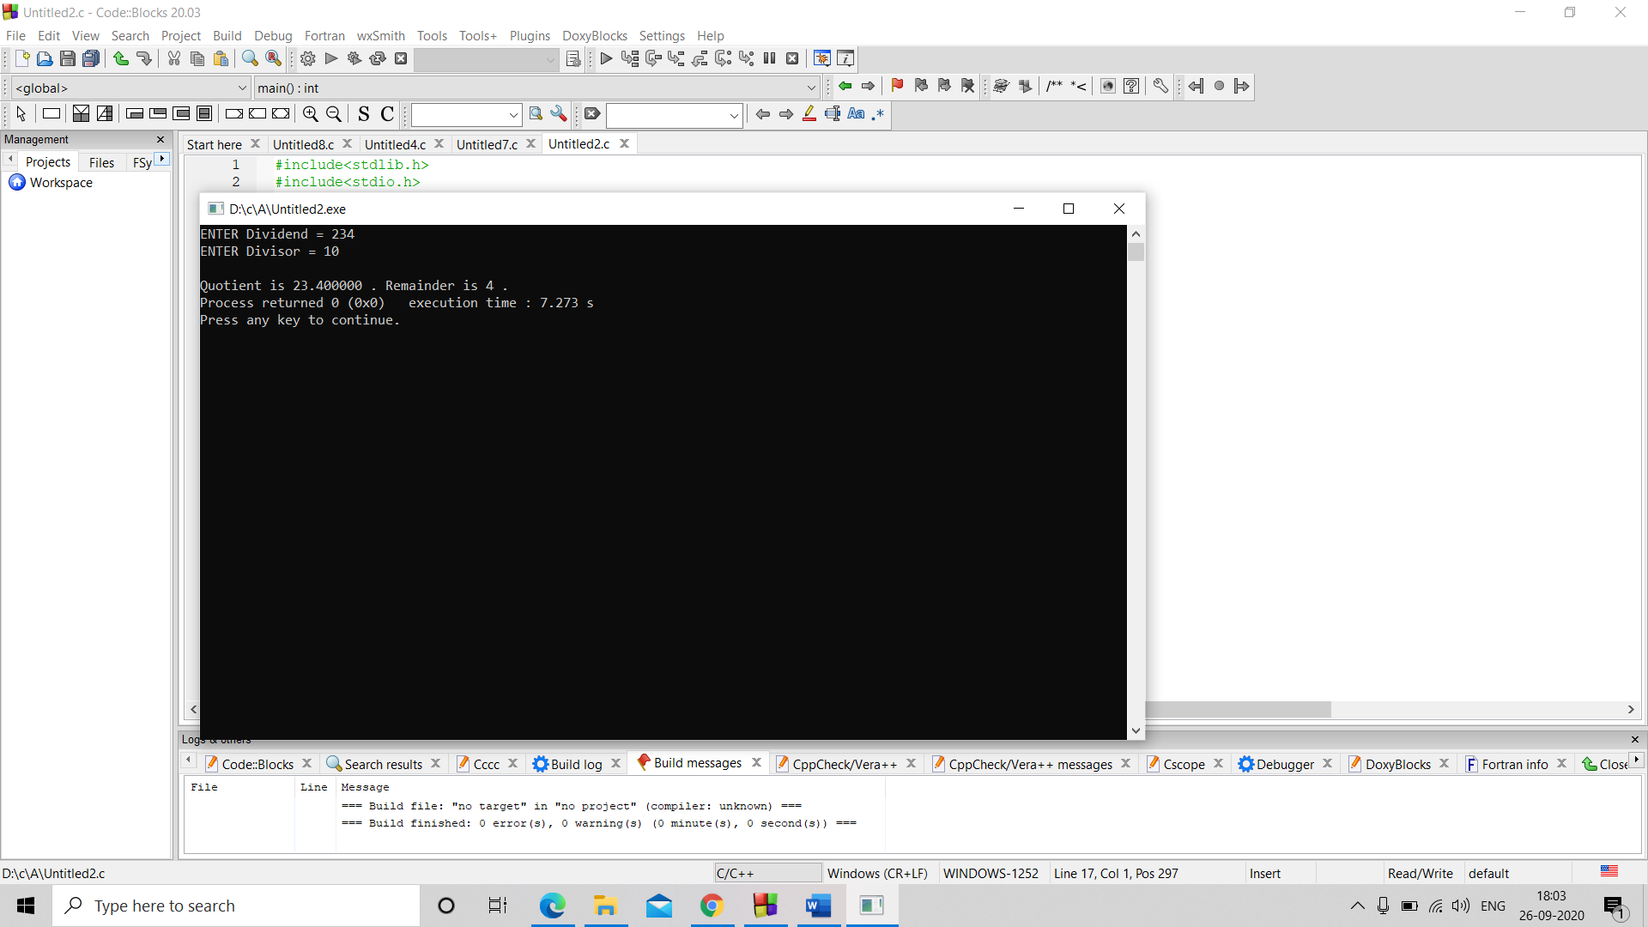{float d,D,Q;

int R;

printf("ENTER Dividend = ");

scanf("%f",&d);

printf("ENTER Divisor = ");

scanf("%f",&D);

Q=d/D;

R=(int)d%(int)D;

printf("\n");

printf("Quotient is %f .",Q);

printf("\t");

printf("Remainder is %d .",R);

return 0;

}

Q4#include<stdlib.h>

#include<stdio.h>

int main()

{

int a,b;

printf("enter 2 numbers : \n");

scanf("%d",&a);

scanf("%d",&b);

printf("\n");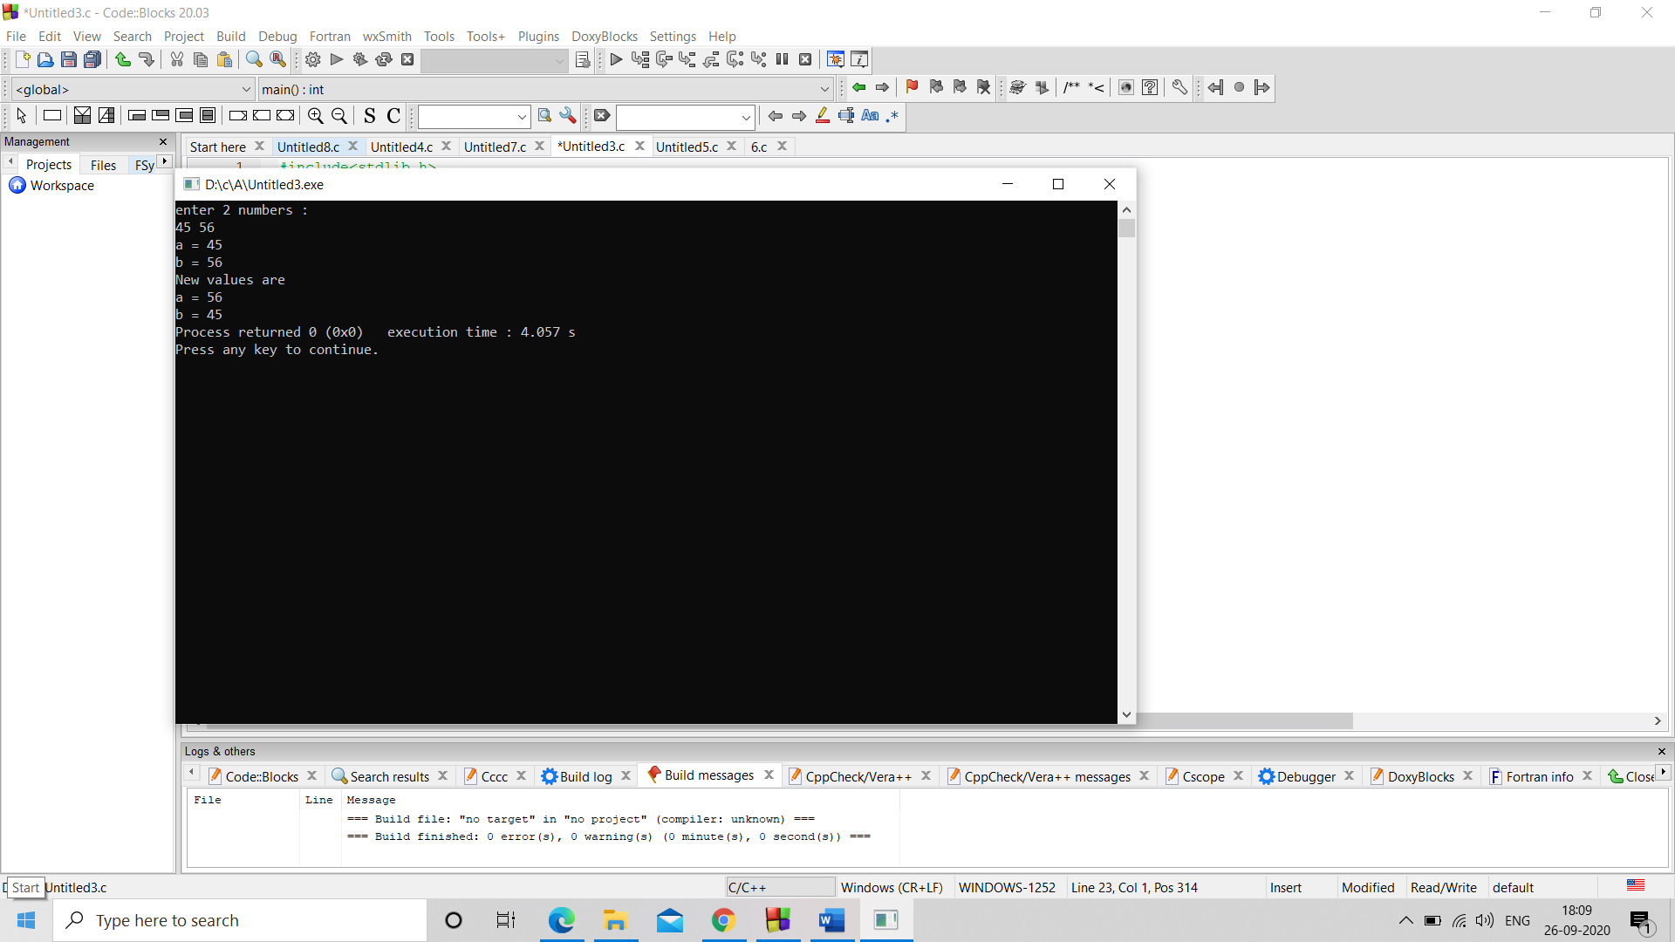

printf(a = "%d",a);

printf("\n");

printf("b = %d",b);

printf("\n");

b=b-a;

a=a+b;

b=a-b;

printf("New values are \n");

printf("a = %d",a);

printf("\n");

printf("b = %d",b);

return 0;

}

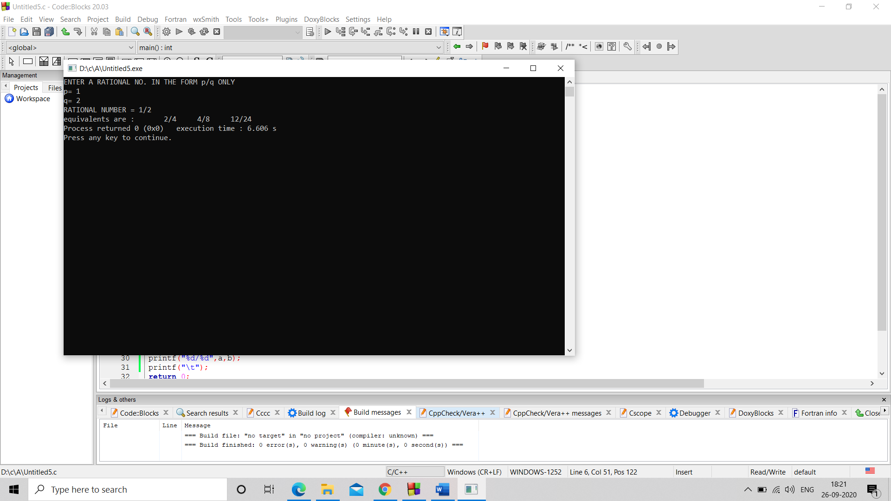 Q5. #include<stdlib.h>

#include<stdio.h>

int main()

{

int a,b,c,d,e,f;

printf("ENTER A RATIONAL NO. IN THE FORM p/q ONLY \n");

printf("p= ");

scanf("%d",&a);

printf("q= ");

scanf("%d",&b);

printf("RATIONAL NUMBER = %d/%d ",a,b);

printf("\n");

a=a*2;

b=b*2;

printf("equivalents are : \t");

printf("%d/%d",a,b);

printf("\t");

a=a*2;

b=b*2;

printf("%d/%d",a,b);

printf("\t");

a=a*3;

b=b*3;

printf("%d/%d",a,b);

printf("\t");

return 0;

}

Q6.

#include<stdlib.h>

#include<stdio.h>

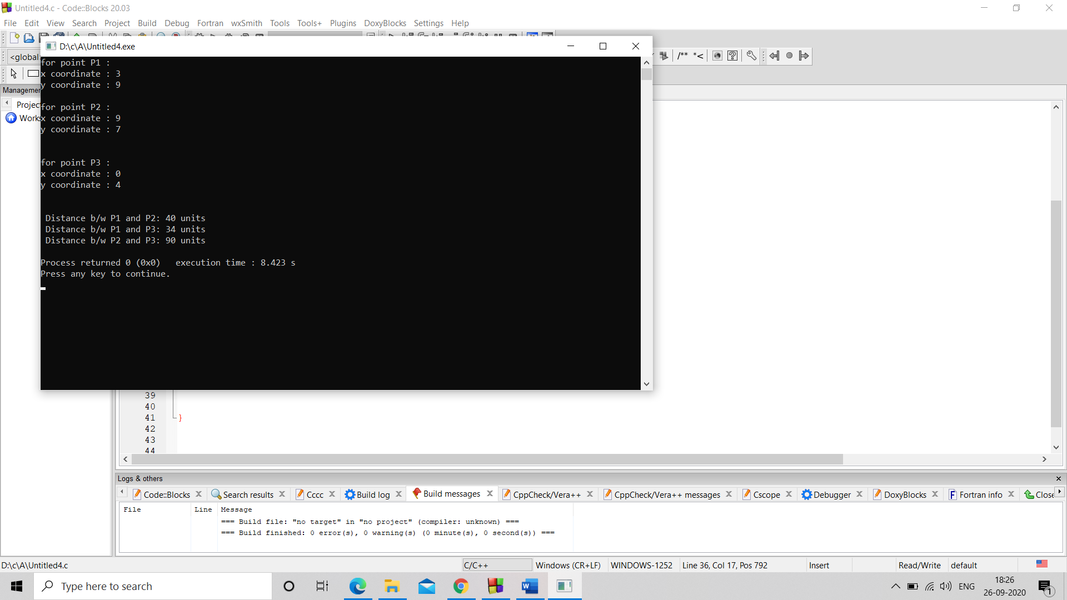int main()

{

int a,b,c,d,D,e,f,D1,D2;

printf("for point P1 : \n");

printf("x coordinate : ");

scanf("%d",&a);

printf("y coordinate : ");

scanf("%d",&b);

printf("\n");

printf("for point P2 : \n");

printf("x coordinate : ");

scanf("%d",&c);

printf("y coordinate : ");

scanf("%d",&d);

printf("\n");

D=((a-c)*(a-c) )+( (b-d)*(b-d));

printf("\n");

printf("for point P3 : \n");

printf("x coordinate : ");

scanf("%d",&e);

printf("y coordinate : ");

scanf("%d",&f);

printf("\n");

printf("\n Distance b/w P1 and P2: ");

printf("%d units ",D);

D1=((a-e)*(a-e) )+((b-f)*(b-f));

printf("\n Distance b/w P1 and P3: ");

printf("%d units",D1);

D2=((c-e)*(c-e))+( (d-f)*(d-f));

printf("\n Distance b/w P2 and P3: ");

printf("%d units",D2);

printf("\n");

return 0;

}

Q7.

#include<stdlib.h>

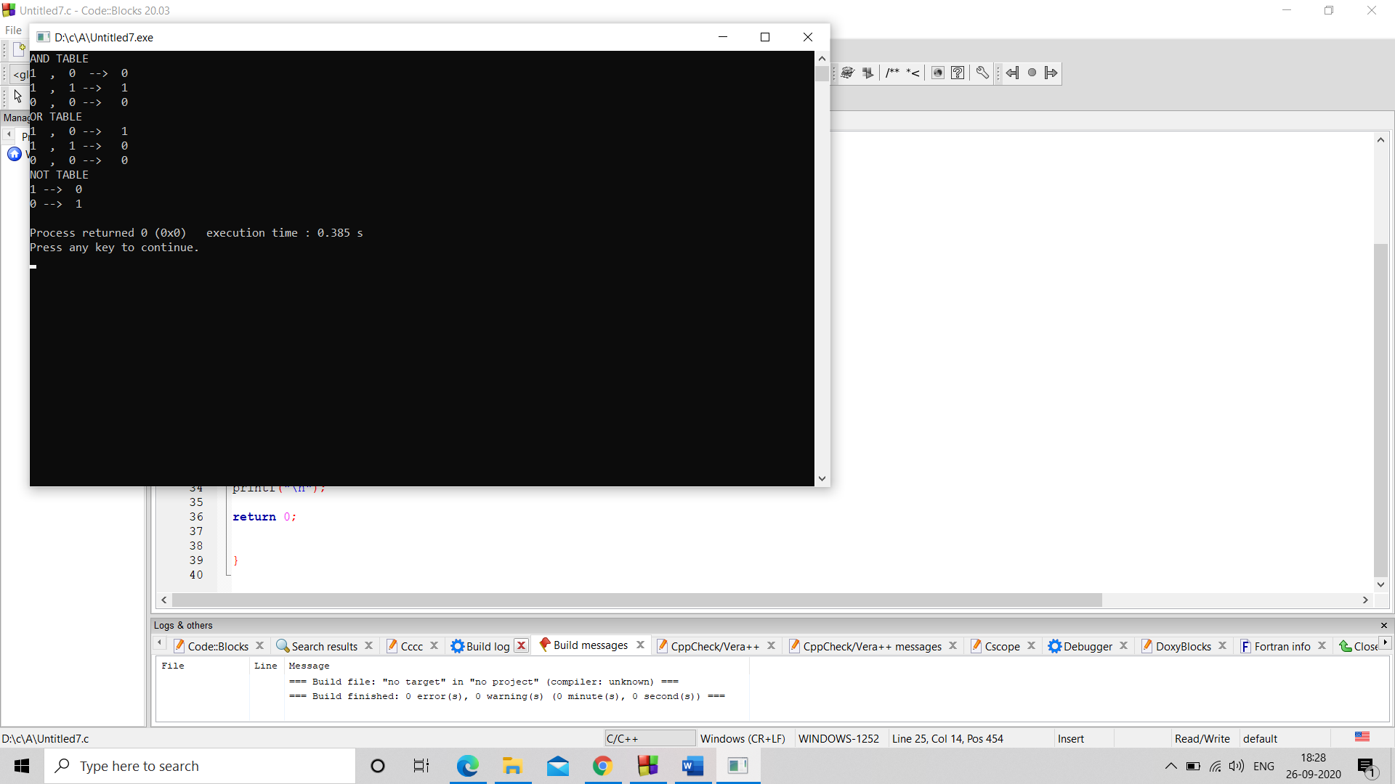#include<stdio.h>

int main()

{int a=1,b=0;

printf("AND TABLE \n");

printf("%d , %d --> %d \n " ,a,b,a&&b);

printf("%d , %d --> %d \n " ,a,a,a&&a);

printf("%d , %d --> %d \n " ,b,b,b&&b);

printf("OR TABLE \n ");

printf("%d , %d --> %d \n " ,a,b,a||b);

printf("%d , %d --> %d \n " ,a,a,b||b);

printf("%d , %d --> %d \n " ,b,b,b||b);

printf("NOT TABLE \n ");

printf("%d --> %d \n " ,a,!a);

printf("%d --> %d \n " ,b,!b);

return 0;

}

Q8.

#include<stdlib.h> // reversing 3 digit no.

#include<stdio.h>

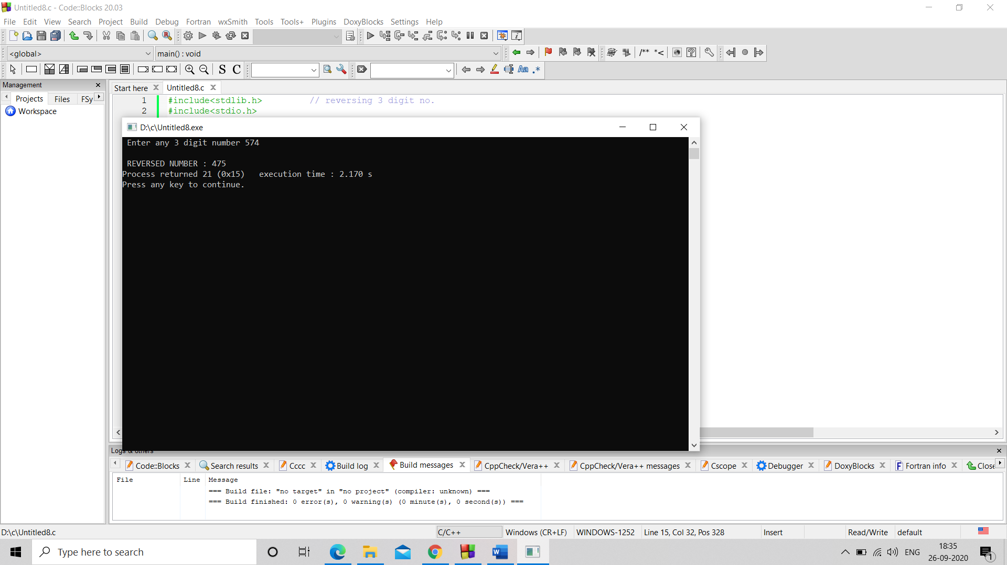void main()

{

int a,b,c,b1,c1,d1,e;

printf(" Enter any 3 digit number ");

scanf("%d",&a);

if(a<1000 && a>99)

{b=a%100;

b1=a/100;

c=b%10;

c1=b/10;

e=c*100+c1*10+b1;

printf(" \n ");

printf("REVERSED NUMBER : %d" ,e);

}

else

printf(" \n INVALID INPUT ");

}